**Homework 4**

**Part 1: Create UI Design**

* This is input screen

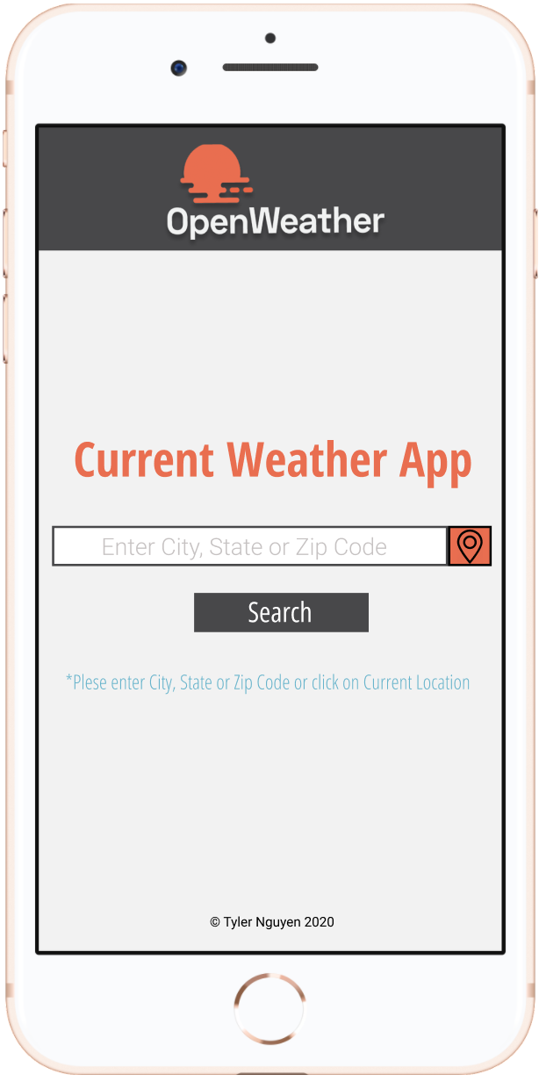

* This is output screen

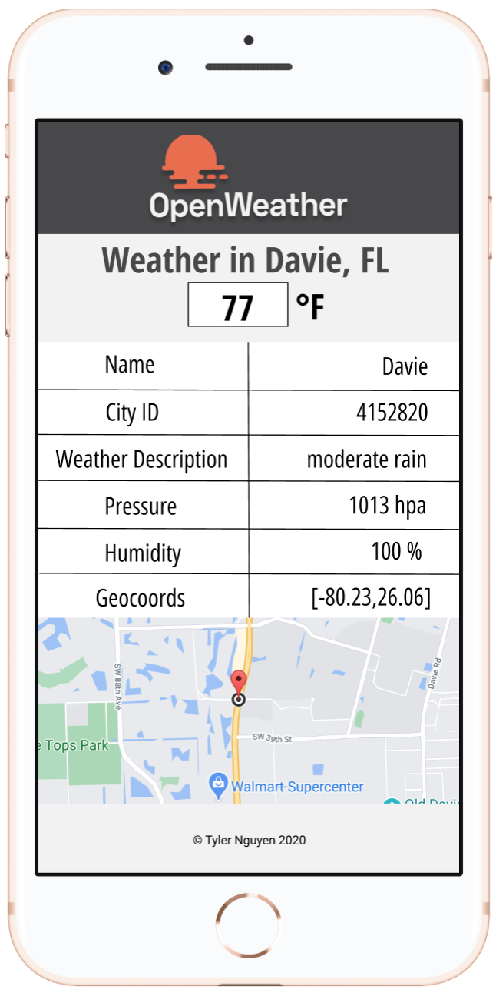

**Part 2: Create App Flow**

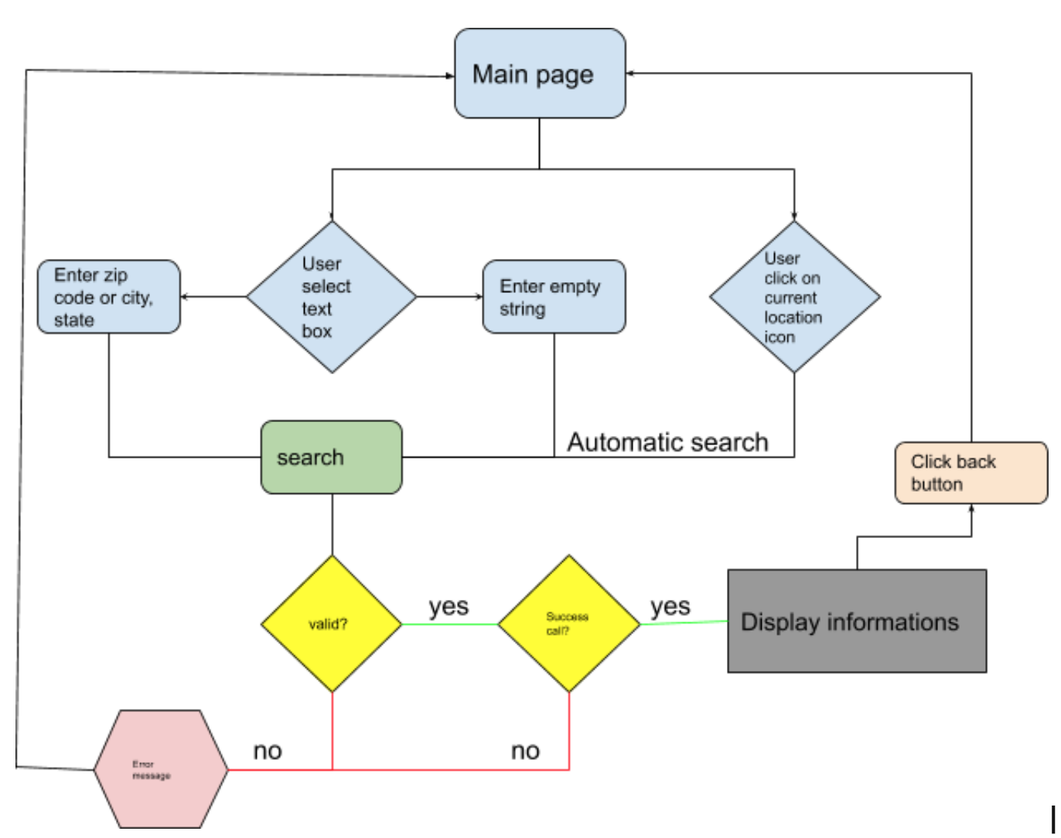

**Part 3: Use OpenWeather API**

